Our Ref: _______________ Your Ref: ________________________ Date: __________________

Baptist Church

Baale Yaku Site Area, P. O. Box 644,

Ogbomoso, Oyo State. Tel. 07052425407

Email: [newsprinbaptistchurch@gmail.com](mailto:newsprinbaptistchurch@gmail.com)

Website: newspringbc.comze.com

NEW SPRING

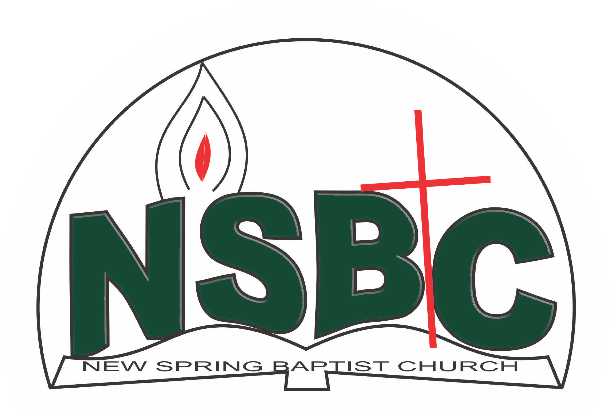

2 January 2022

Dear Pastor Paul Adeoye,

Nomination to Serve as a Worker in the Church in 2022.

Calvary greetings in the precious name of our Lord and Saviour Jesus Christ. It is our pleasure to inform you that at the Church-in-Conference held on December 19, 2021, the Church ratified your nomination to serve in the following areas between January 1 and December 31 2022:

1. Children Pastor, Children Department under the leadership of Revd. Kayode Oke
2. Member, Church Council under the Chairmanship of Rev. Kayode Oke

Please refer to the table below for the key functions of each of these roles. Details can be found in the Church constitution. You are strongly encouraged to become familiar with the tasks as stated in the document. There will be an orientation of the Church workers on January 22, 2022 at 8:30 a.m. on the church premises. Please ensure you participate in this training.

“Now it is required that those who have been given a trust must prove faithful. I Corinthians 4:2”. May God find you faithful in the task He has assigned to you.

| Domain | Key function of Office, Department or Committee |
| --- | --- |
| Children Pastor | To assist the Church Pastor (undershepherd) in ministry to the children in the Church. |
| Church Council | The Church Council is the governing body of the Church whose membership, under the leadership of the Holy Spirit, holds one another mutually accountable with respect and love and sees to the smooth running of the Church. |

Thank you for accepting to serve in this Church.

Yours in His service

Olusayo Okediji Blessed Agboola

Church Secretary                                                                                     Chairman, Nominating Committee 2 January 2022

Dear Mrs. Comfort Majekolagbe,

Nomination to Serve as a Worker in the Church in 2022.

Calvary greetings in the precious name of our Lord and Saviour Jesus Christ. It is our pleasure to inform you that at the Church-in-Conference held on December 19, 2021, the Church ratified your nomination to serve in this area between January 1 and December 31,2022:

1. Children’s Worker under the leadership of Pst. Paul Adeoye
2. Sunbeam Leader

Please refer to the table below for the key functions of each of these roles. Details can be found in the Church constitution. You are strongly encouraged to become familiar with the tasks as stated in the document. There will be an orientation of the Church workers on January 22, 2022 at 8:30 a.m. on the church premises. Please ensure you participate in this training.

“Now it is required that those who have been given a trust must prove faithful. I Corinthians 4:2”. May God find you faithful in the task He has assigned to you.

| Domain | Key function of Office, Department or Committee |
| --- | --- |
| Children’s Department | The committee is responsible for organizing activities that contribute to the spiritual nurture of children from birth to 12 years. |
| Sunbeam Leader | Work with the WMU President for the spiritual nurture of children |

Thank you for accepting to serve in this Church.

Yours in His service

Olusayo Okediji Blessed Agboola

Church Secretary Chairman, Nominating Committee